1. Mechanical Basics
1 Pipe and Tube
Aspect | Pipe | Tube
Primary Purpose | Transporting fluids or gases | Structural applications and precision work
Sizing | Based on nominal diameter (NPS) | Based on actual outside diameter (OD)
Wall Thickness | Specified by schedule (e.g., SCH 40) | Specified by gauge or direct thickness
Tolerance | Looser tolerances | Tighter tolerances for OD, ID, wall thickness
Shape | Mostly round | Round, square, rectangular, oval, etc.
Standardization | ANSI/ASME B36.10M, B36.19M | ASTM A269, A554, etc.

Using Pipe: Transporting fluids/gases.
• Transporting fluids, steam, oil, gas, water, etc.
• Pressure and flow rate are critical.
• You are working with plumbing, process piping, or HVAC systems.

Using Tube: Structural， precision, or aesthetic needs.
• Structural applications or need tight dimensional control.
• Aesthetic appearance or precision is important (e.g., handrails, medical devices).
• You need custom shapes or lightweight materials.

Description both of them in BOM:
SS Pipe 3” Sch. 40
SS Sanitary Tube 3” (Sanitary is only based on requirement)

(The Details Showing in Table 1 refer to Appendix)

2 Sheet Metal, Plate, Flat Bar
Feature | Sheet Metal | Plate | Flat Bar
Definition | Thin, flat rolled metal | Thick, flat rolled metal | Long, rectangular section with set width and thickness
Thickness | < 3 mm (typically) | ≥ 3 mm (varies by standard, often 6+ mm) | Varies, often 3–25 mm; defined cross-section
Form | Supplied in sheets or coils | Supplied in flat sheets or plates | Supplied as bars (long strips)
Common Shapes | Rectangular sheets or coils | Rectangular sheets | Rectangular cross-section (e.g., 25×3 mm)
Use Case | Ductwork, panels, enclosures | Heavy-duty parts, structural components | Brackets, stiffeners, supports
Processing | Often cut, bent, or stamped | Machined, drilled, welded | Cut, drilled, welded

Description of them in BOM:
SS SHT 12 Gauges(Ga) (2B) (2B is surface treatment)
SS Plate 3/8” x 7” x 10” (Here is thickness x width x length, in general, SS Plate 3/8”)
SS Flat Bar (F.B.) 7” x 3” x 10” (Here is width x thickness x length)

3 Bolt and Screw
Term | Description | Typical Use Case
Screw | A fastener with external threads that engages directly into a material (e.g., wood, plastic, metal). Often forms its own mating thread. | Fastening into tapped holes or soft material
Bolt | A fastener with external threads designed to be used with a nut (or into a pre-tapped hole). Typically, not self-tapping. | Clamping parts together with nut & washer
Thread | The helical ridge on a screw/bolt or inside a nut/hole. Can be external (male) or internal (female). | Allows mating between components
Stud  (Ready Rod) | A rod threaded on both ends (or sometimes fully). One end screws into a part; the other receives a nut. No head. | Engine blocks, heavy equipment, flanged joints


Description of them in BOM:
2 x M3 x 1.25-6H/7g-LH ↓5 (Completely Penetrate)
¼ NPT↓5” ┕┙↓2
3/8 NPS↓5” Hole↓7”

Abbreviation | Full Name | Thread Type | Application | Tapered | Units
NPT | National Pipe Taper | Pipe thread (tapered) | Sealing for fluid/gas (tight fit) | ✅ | Inch
NPS | National Pipe Straight | Pipe thread (straight) | Fluid/gas with gasket/seal | ❌ | Inch
UNC (NC) | Unified National Coarse | Fastener thread | General bolts/screws (coarse pitch) | ❌ | Inch
UNF (NF) | Unified National Fine | Fastener thread | Precision bolts/screws (fine pitch) | ❌ | Inch
UNEF | Unified National Extra Fine | Fastener thread | High precision/light duty | ❌ | Inch
M | Metric Thread | Fastener thread | International bolts/screws | ❌ | Metric
BSPT | British Standard Pipe Taper | Pipe thread (tapered) | British/international pipe sealing | ✅ | Inch (British)
BSPP | British Standard Pipe Parallel | Pipe thread (straight) | British fittings with gasket | ❌ | Inch (British)

1/2"-14 NPT → Tapered pipe thread, 1/2 inch nominal size, 14 threads per inch
3/4"-10 UNC → Coarse threaded bolt, 3/4 inch diameter, 10 TPI
M8 × 1.25 → Metric bolt, 8 mm diameter, 1.25 mm pitch
1-NPS → Straight pipe thread, 1 inch nominal size

板子的厚度 = 1~1.5螺纹孔的直径
$$L_{e}≈1.5\sim 2d \left(L_{e}​ 是有效螺纹长度, 啮合深度\right) d为螺纹公称直径$$

4 Form & Location Tolerance
① Form Tolerance
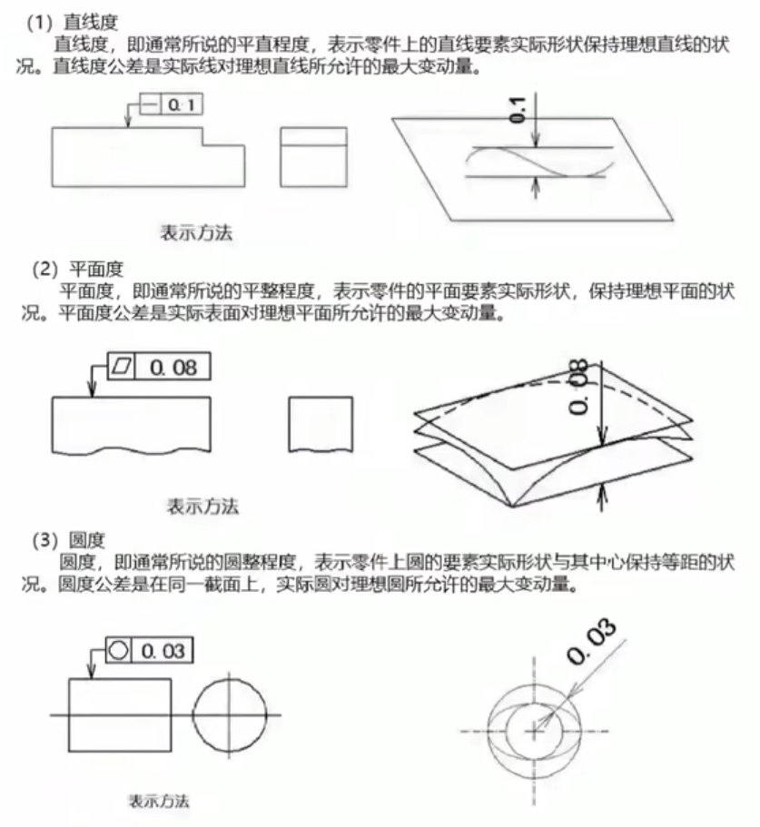

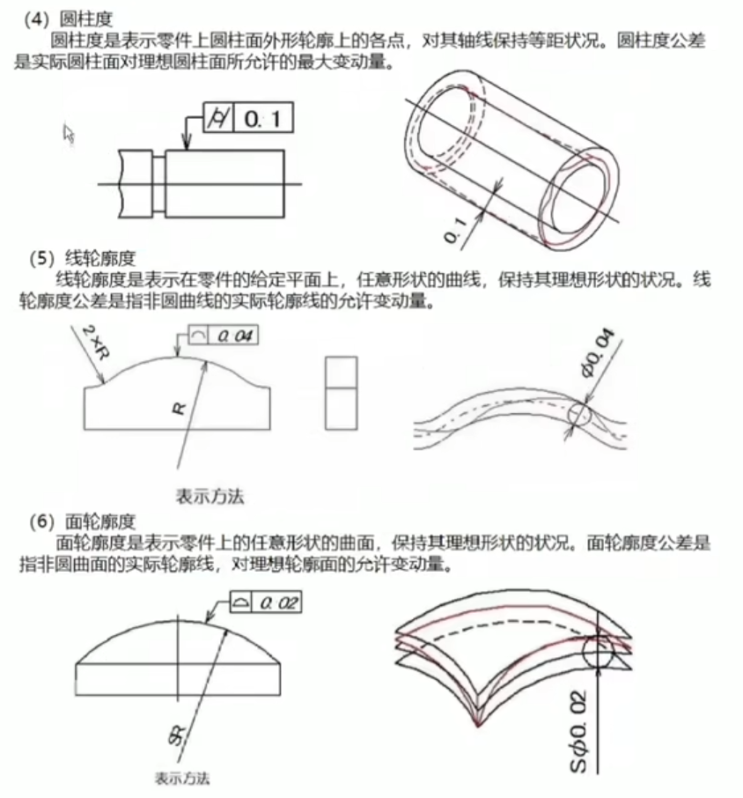

② Location Tolerance
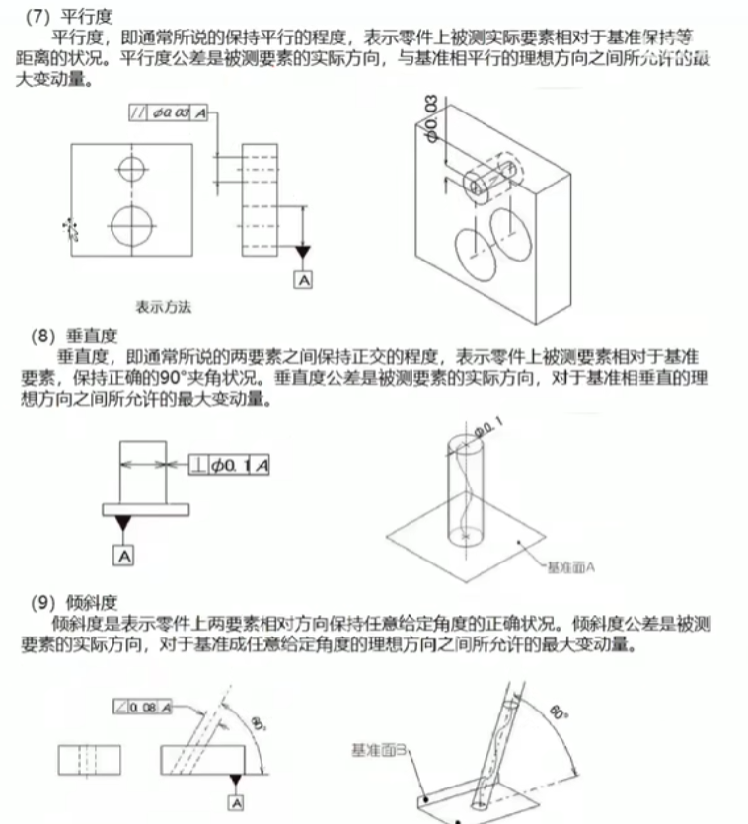

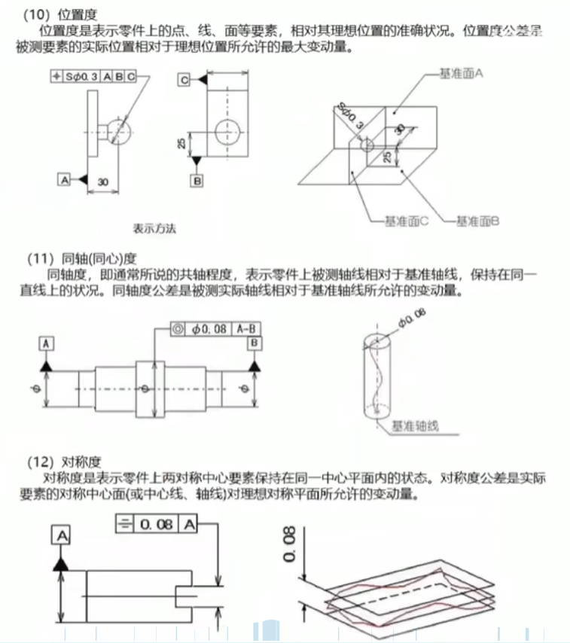

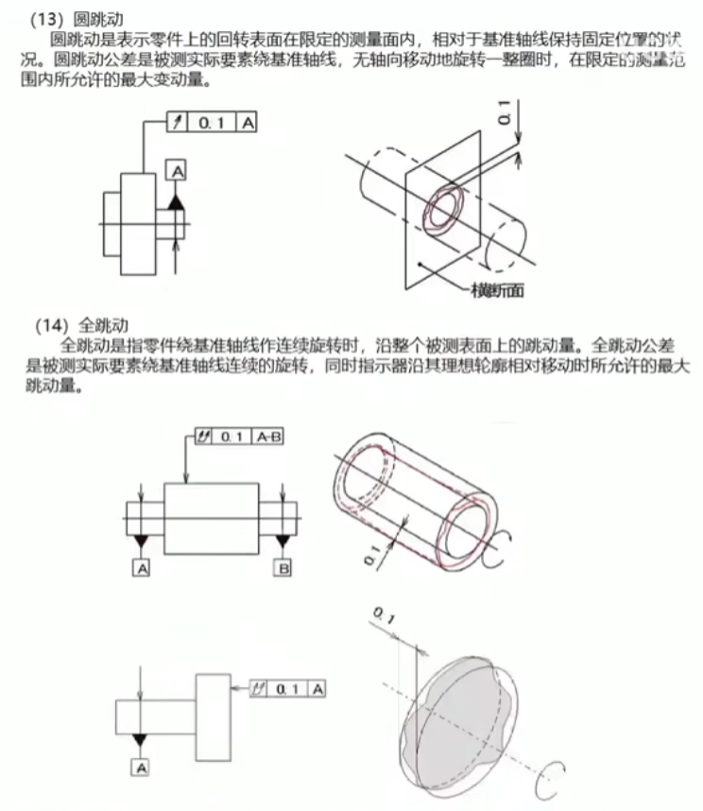

5 Pump & Motor
5.1 General Type of Pump
Pump Type | Drive Method | Description
Centrifugal Pump | Impeller directly driven by motor shaft | Most common pump type, fill water inside
Self-Priming Pump | Motor drives impeller + vacuum chamber | Can draw water even when initially dry
Piston / Gear Pump | Motor drives piston or gear mechanism | Used for high-pressure or special fluids
Submersible Pump | Pump and motor integrated, submerged | Motor operates underwater , used in wells, ponds
DC Micro Pump | Motor and pump molded as one (12V/24V) | Commonly used in small projects or models

Pump needs motor to drive it.

5.2 Calculating the Motor’s Power
- Total Head (pump height)
- Flow Rate (e.g. L/min)
- Power Suppl Type (e.g. 220V AC)
- Application Scenario (Irrigation, drawing water from a well, etc.)

$$P= \frac{ρghQ}{η} (h=H_{actual}+H_{loss}; H_{loss}=0.3\sim 0.5∙H_{actual})$$

5.3 How to Choose the Type of Pump
Step |  | Description | Example
1 | Define the Application | Pumping, irrigation, water supply, cooling, sewage, circulation? | Example: Irrigation for an orchard
2 | Determine Basic Parameters | - Head H (meters) - Flow Rate Q (L/min or m³/h) - Fluid Type | Need to pump water up to 8 meters, 3 m³/h flow, clean water
3 | Choose Installation Type | - Surface pump / submersible pump / horizontal pump - Self-priming required? | Surface self-priming pump, drawing from a pond
4 | Power Supply | 220V single-phase? 380V three-phase? 12V/24V DC? | 220V household AC available
5 | Match Pump Model | Select model using manufacturer’s catalog (or estimate using empirical formulas) | Match model: JET100, ISG, QB series, etc.

Scenario | Recommended Pump Type
Need to draw water from a low source | Self-priming pump (e.g., JET, WZB series)
Need to pump water far and high | Multistage centrifugal pump
Pump needs to work underwater | Submersible pump (e.g., QDX, QY series)
Water contains particles or sludge | Sewage pump / slurry pump
Small-scale irrigation or dispensers | Mini DC pump (12V / 24V)

The motor choosing is based on the Pump type.

6 Gear, Sprocket, & Bear
Choosing the Sprocket is based on the allowed torque, and transmission ratio.

The torque of sprocket is:
$$P=T∙ω, ω=\frac{2πn}{60} ≈ (n is rmp)$$
$$T_{real}=K_{s}∙T (K_{s} is the service factor)$$
$$T_{real}≤T_{max⁡_allow}$$
小链轮推荐齿数：
工业场合推荐：≥ 17 齿
尽量不要 < 13 齿，避免弯曲疲劳过大

7 Plastic Material
Common Plastic Materials – Properties, Applications & Design Notes
Material | Key Properties | Typical Design Applications | Design Considerations
ABS (Acrylonitrile Butadiene Styrene) | Good moldability, good surface finish, moderate rigidity | Toys, appliance housings, handles | Poor UV resistance, prone to aging
PP (Polypropylene) | Lightweight, chemical-resistant, low cost, live hinge capable | Food containers, hinge structures (e.g. stationery lids) | High shrinkage, difficult to paint
PC (Polycarbonate) | High strength, transparent, impact-resistant, heat-resistant | Protective covers, light housings, transparent parts | Expensive, prone to stress cracking during processing
PA (Polyamide / Nylon) | High toughness, wear-resistant, heat-resistant, hygroscopic | Gears, sliders, industrial components | Moisture absorption causes dimensional changes
PMMA (Acrylic) | High transparency, hard and brittle, scratch-prone | Display cases, lightboxes, signage | Brittle, poor impact resistance
POM (Polyoxymethylene / Acetal) | High strength, low friction, dimensional stability | Bearings, slides, mechanical parts | Requires careful mold release design
TPU (Thermoplastic Polyurethane) | Excellent elasticity, abrasion resistance, anti-slip, flexible & dyeable | Phone cases, shoe soles, sports accessories | Slightly expensive, narrow processing window
PETG (Glycol-modified PET) | Impact-resistant transparent plastic, between PC and PMMA | Transparent containers, medical parts, 3D printing | Tends to string, poor resistance to strong acids
PE (HDPE/LDPE) | Chemically resistant, low friction, tough | Bottle caps, piping, children's toys | Poor adhesion, difficult to paint

Choosing Plastic Material From Various Aspect
Category |  | Description | Recommended Materials
1 | Mechanical Properties | Need for high strength or toughness | PC (impact resistant), PA (high strength), POM (rigid)
2 | Transparency | Need to see internal structures | PMMA, PC (high transparency)
3 | Surface Finish | Need for plating, painting, or etching | ABS (excellent for plating), PC+ABS (great for painting)
4 | Heat Resistance | Must withstand temperatures above 80°C | PC, PPS, PEI
5 | Weather Resistance | Outdoor use requiring aging resistance | ASA, modified PP, UV-stabilized PC
6 | Flame Retardancy | UL94 flame resistance required | Flame-retardant ABS, FR-PC, PA66 FR
7 | Processing Method | Type of process: injection, blow, extrusion | ABS/PP (injection molding), PE (blow molding)
8 | Environmental & Food Safety | Requires ROHS/REACH/FDA compliance | PP, HDPE, TPU

Application | Recommended Materials | Reasons
Toys / Figures | ABS, PVC, PU | Easy to mold, good surface finish options
Medical Device Housings | PC, ABS, PC+ABS | Impact resistant, good formability
Transparent Covers / Lamps | PC, PMMA | High transparency, UV resistant
Industrial Parts (Gears/Fasteners) | POM, PA66 | High rigidity, wear resistant
Daily-use Containers (Food Grade) | PP, PE | Non-toxic, acid/alkali resistant
Electronics Housings | PC+ABS, ASA | Impact resistant, easy to process

The Method of Figure Crafting
Material Name | Key Properties | Typical Use
PU Cast Resin (Polyurethane Resin) | Most used for casting, high flowability, fast curing, excellent detail replication | Small-batch casted figure parts
PVC (Polyvinyl Chloride) | Thermoplastic, moldable under heat and pressure, good hand feel, low cost | Mass-produced commercial figures (most finished figures)
ABS (Acrylonitrile Butadiene Styrene) | Good rigidity, impact resistance, suitable for structural parts | Joints, movable mechanisms, weapon accessories
POM (Polyoxymethylene / Acetal) | Ultra-low friction, high wear resistance, mechanically robust | Joint connectors (e.g. articulated action figures)
Silicone (for molds) | Soft, excellent mold release, heat-resistant, high-detail replication | Mold-Making material (not for final parts!)

① Small-Batch Figure Production → PU Resin + RTV Silicone Mold
Step 1: Create the Master Prototype
Use sculpting clay (e.g., oil-based clay or epoxy putty) or print the master model using a high-detail SLA 3D printer.

Step 2: Make the Silicone Mold
Encapsulate the master with two-part RTV silicone (room-temperature vulcanizing silicone).
Vacuum degas to remove air bubbles. Once cured, cut open the mold and remove the master.

Step 3: Resin Casting (Pouring PU Resin)
Mix PU resin parts A and B (e.g., Smooth-On series) and pour into the mold.
The resin cures quickly (within 3 to 10 minutes).
Demold → Trim → Sand the part.

Step 4: Painting and Finishing
First, spray a primer (gray primer like Mr. Surfacer is recommended).
Then paint using model paints (e.g., Mr. Hobby, Tamiya).
Finally, apply a topcoat for protection.

② Mass Production of Commercial Figures → PVC Injection Molding + Metal Molds (Standard Process Used by GSC, ALTER, Kotobukiya, etc.)
Step 1: Create a Digital Model (e.g., using ZBrush, Blender)
3D modeling and digital sculpting → Export slicer-ready files.

Step 2: CNC Machining of Steel Mold
High-precision steel molds are made using CNC milling and electrical discharge machining (EDM).
Mold production is expensive (ranging from tens of thousands to hundreds of thousands of RMB).

Step 3: PVC Heat Injection Molding
PVC pellets (with added plasticizers for softness) are preheated and injected into the mold under high pressure.
After cooling, the parts are demolded → Basic shaping is complete.

Step 4: Flash Removal & Assembly
Manual trimming, assembling parts, drilling holes — may include internal metal rods or supports.

Step 5: Painting (Mostly Spray + Pad Printing)
Mostly done via automated spray painting, masking templates, and hand-painted detail work.

The Comparison of PU & PVC for Figure Production
Aspect | PU Resin | PVC (Industrial Mass Production)
Stage | Prototype making + small-batch casting | Mass production (e.g., GSC figures)
Mold Type | RTV silicone mold (flexible) | Hard metal mold (expensive)
Processing Method | Manual pouring, room temperature curing | High-temperature injection molding or heat press casting
Detail Quality | Excellent — ideal for sculpting prototypes or high-precision, low-volume items | Also, excellent — especially for large, complex parts
Disadvantages | High material cost, low efficiency, prone to aging/yellowing | Very expensive molds, high equipment requirements, unfriendly DIY

8 Metal Material
1. General Metal Material Properties
Category | Common Metals |  | Key Properties | Application Fields
Carbon Steel | Q235, 45# Steel | High strength, low cost, weldable, prone to rust |  | Structural components, welded structures, shafts
Alloy Steel | 40Cr, 20CrMo | High strength, good after heat treatment, wear-resistant |  | Gears, bearings, connecting rods, heavy-duty parts
Stainless Steel | 304, 316 | Corrosion-resistant, aesthetic, expensive, hard to machine |  | Food equipment, medical devices, decorative casings
Aluminum Alloy | 6061, 7075 | Lightweight, good thermal conductivity, corrosion-resistant, easy to machine |  | Aerospace parts, structural components, laptop housings
Copper Alloy | Brass, Copper (Red) | Excellent electrical and thermal conductivity, corrosion-resistant, expensive |  | Electrical connectors, heat exchangers, plumbing fittings
Magnesium Alloy | AZ91D | Ultra-lightweight, good damping, oxidizes easily, recyclable |  | Portable devices, aerospace, 3C electronics
Titanium Alloy | TC4 (Ti6Al4V) | High strength, corrosion-resistant, biocompatible, very expensive |  | Aerospace, medical implants, precision machinery
Zinc Alloy | Zamak 3, etc. | Easy to die-cast, low cost, good decorative finish |  | Toys, decorative parts, hardware components

2. Main Performance Indication
Performance Index |  | Meaning & Applications
1 | Tensile Strength | Ability to withstand pulling force; used to evaluate structural strength requirements
2 | Yield Strength | The limit between elastic and plastic deformation; determines if a material will “spring back”
3 | Hardness | Resistance to indentation or scratching; indicates wear resistance
4 | Ductility / Plasticity | Tendency to stretch without breaking; important for formed or stamped parts
5 | Density | Mass-to-volume ratio; crucial for lightweight design
6 | Thermal Conductivity | Rate of heat transfer; affects heat sinks and cookware materials
7 | Electrical Conductivity | Ability to conduct electricity; critical for electronics and wiring
8 | Corrosion Resistance | Resistance to rust or chemical attack; essential for outdoor or humid environments
9 | Weldability | Ease of joining by welding
10 | Machinability | Suitability for milling, turning, stamping, forging, casting, etc.

Application Recommends

Application Scenario |  | Recommended Metal Materials | Brief Reason
1 | Toy Structures | Aluminum Alloy, Zinc Alloy | Lightweight, easy to process, safe
2 | Mechanical Components | Alloy Steel, Carbon Steel | High strength, good machinability
3 | Corrosive Environments (e.g. seaside) | Stainless Steel 316, Titanium Alloy | Excellent corrosion resistance
4 | Laptop Housings | Aluminum Alloy, Magnesium Alloy | Lightweight, aesthetic, easy for CNC
5 | Electrical Connectors | Copper, Copper Alloys | Excellent conductivity, corrosion-resistant
6 | Precision Aerospace Parts | Titanium Alloy, 7075 Aluminum | High strength, lightweight

Tips: Material Selection Advice for Designers
- Structure + Cost Priority: Use carbon steel or alloy steel.
- Aesthetic + Corrosion Resistance: Choose stainless steel or anodized aluminum.
- High Thermal/Electrical Conductivity: Copper is the top choice.
- Lightweight + High Formability: Go for aluminum, magnesium, or zinc alloys.
- Decorative Parts with Complex Surface Details: Use zinc alloy die-casting.
- High-End / Medical-Grade Requirements: Option for titanium alloy.

